EXP.NO: 4

TO FIND DFT / IDFT OF GIVEN DT SIGNAL

AIM: To find Discrete Fourier Transform and Inverse Discrete Fourier Transform of given digital signal.

Software: MATLAB

THEORY:

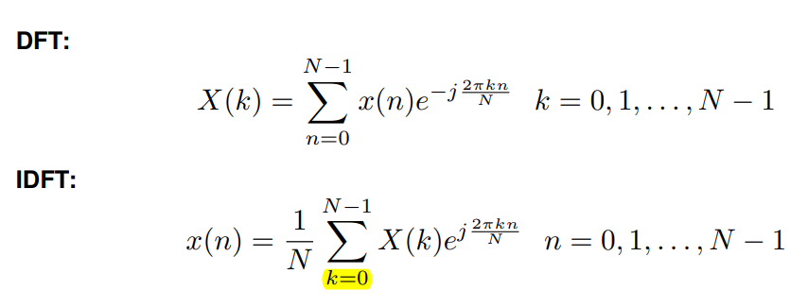

Algorithm:

Step I: Get the input sequence.

Step II: Find the DFT of the input sequence using direct equation of DFT.

Step III: Find the IDFT using the direct equation.

Step IV: Plot DFT and IDFT of the given sequence using matlab command stem.

Step V: Display the above outputs.

## PROGRAM:

clc; close all; clear all;

xn=input('Enter the sequence x(n)'); %Get the sequence from user ln=length(xn); %find the length of the sequence

xk=zeros(1,ln); %initialize an array of same size as that of input sequence ixk=zeros(1,ln); %initialize an array of same size as that of input sequence

%DFT of the sequence

%-----------------------------------------------------

for k=0:ln-1 for n=0:ln-1

xk(k+1)=xk(k+1)+(xn(n+1)*exp((i)*2*pi*k*n/ln)); end

end

%------------------------------------------------------

%Plotting input sequence

%-----------------------------------------------------

t=0:ln-1; subplot(221); stem(t,xn);

ylabel ('Amplitude'); xlabel ('Time Index'); title('Input Sequence');

%---------------------------------------------------------------

magnitude=abs(xk); % Find the magnitudes of individual DFT points

% plot the magnitude response

%------------------------------------------------------------

t=0:ln-1; subplot(222); stem(t,magnitude); ylabel ('Amplitude'); xlabel ('K');

title('Magnitude Response');

%------------------------------------------------------------

phase=angle(xk); % Find the phases of individual DFT points % plot the magnitude sequence

%------------------------------------------------------------

t=0:ln-1; subplot(223); stem(t,phase); ylabel ('Phase');

xlabel ('K');

title ('Phase Response');

%------------------------------------------------------------

%IDFT of the sequence

%------------------------------------------------------------

for n=0:ln-1 for k=0:ln-1

ixk(n+1)=ixk(n+1)+(xk(k+1)*exp(i*2*pi*k*n/ln)); end

end ixk=ixk./ln;

%------------------------------------------------------------

%code block to plot the input sequence

%------------------------------------------------------------

t=0:ln-1; subplot(224); stem(t,ixk);

ylabel ('Amplitude'); xlabel ('Time Index'); title ('IDFT sequence');

%------------------------------------------------------

## Output:

Xn=[1 2 3 4 5]

Xk = 15,-2.50+3.44i,-2.50+0.81i,-2.49-0.81i,-2.49-3.44i

## VIVA QUESTIONS:

* 1. Define signal, Give Examples for 1-D, 2-D, 3-D signals.
  2. Define transform. What is the need for transformation?
  3. Differentiate Fourier transform and discrete Fourier transform.
  4. Differentiate DFT and DTFT
  5. Explain mathematical formula for calculation of DFT.
  6. Explain mathematical formula for calculation of IDFT.
  7. How to calculate FT for 1-D signal?
  8. What is meant by magnitude plot, phase plot, power spectrum?
  9. Explain the applications of DFT.
  10. What are separable transforms?

# Exercise:

1. Find 8-point DFT of the sequence x (n) = [1 2 3 4 4 3 2 1]